

**Team 5 [Mahmoud Adel & Yomna Magdy]**

**Facilitators: [Nadine Essam & Ahmed Emad]**

**Game:**

**Mouse Escaping**

* **Setup the game:**

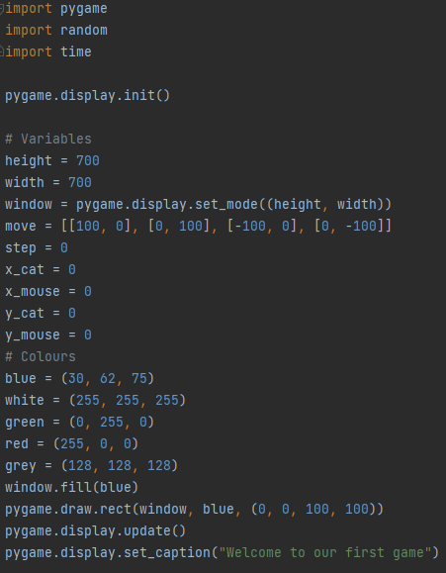

**In This Code:**

1. **First, We Import These Libraries [pygame, random, time]**
2. **We initialized pygame modules**
3. **We gave some variables to objects to make it easy for us to use them**
4. **We fill the window with blue**
5. **We set caption to our game**

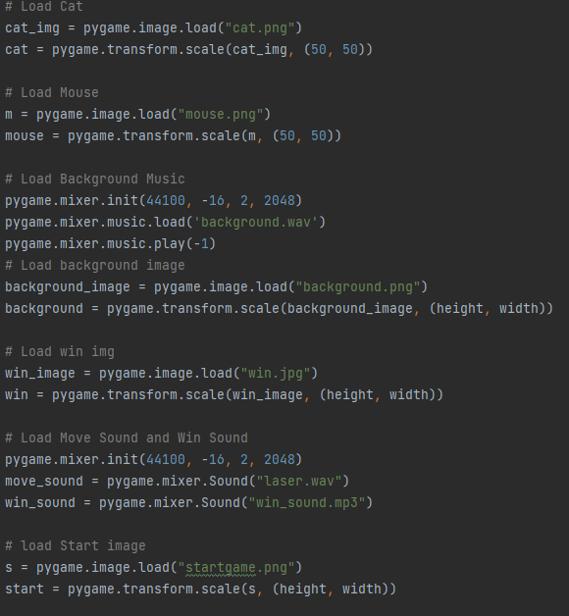

**In This Code:**

1. **We Loaded All media needed to play the game [Cat, Mouse, Music, Images, Sound]**
2. **We play the background music**
3. **We gave variables to images to use them**

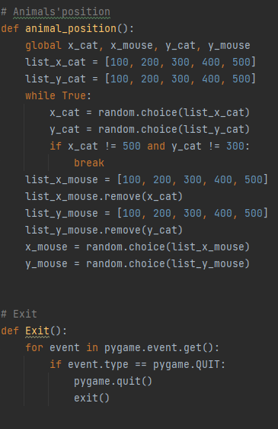

**In This Code:**

1. **We make a function for animal position [ Cat and Mouse]**
2. **Mouse and Cat take a random place at the first of the game**
3. **We made the cat can’t take the place that front of the win block**
4. **We made the mouse can’t take the cat place at the first of the game [By removing the positions of the cat]**
5. **We made a function for exit the game**

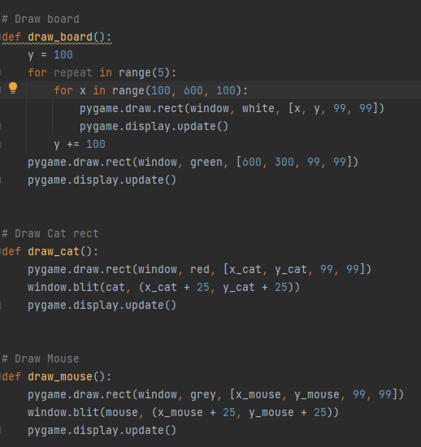

**In This Code:**

1. **We draw the components of our game [Grid, Cat, Mouse] and put them in functions**

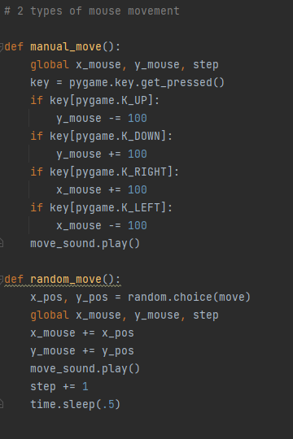

**In This Code:**

1. **We make the movements of the mouse in functions to use them later [Two options: Random and Manual]**
2. **We add sound after moving**

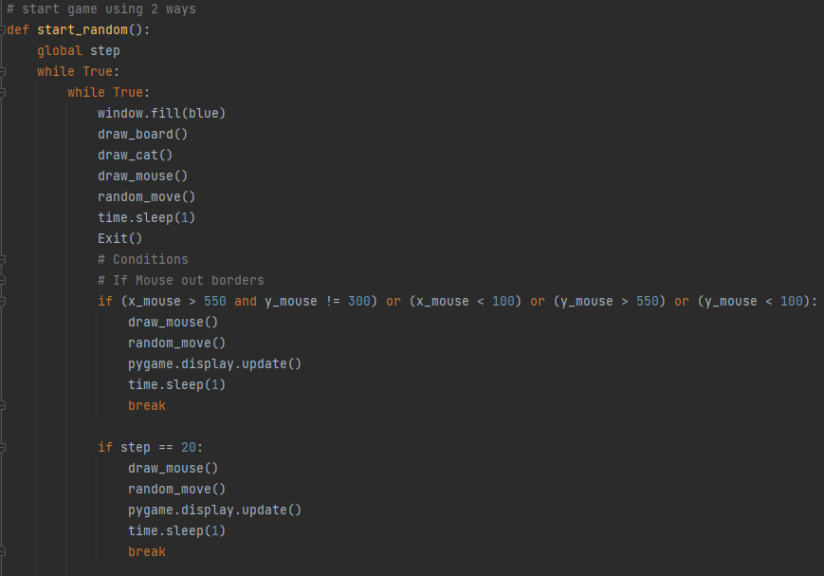

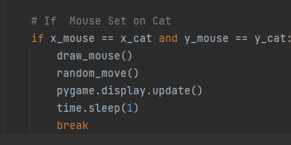

**In This Code:**

**We make a function to use it later when the user chooses the random scenario.**

1. **Some function we explain them before.**
2. **We put some conditions to the mouse:**
3. **If the mouse went out to border, or moved 20 steps without reaching to the win block, or touched the cat, he will lose and the game will show a loser background.**

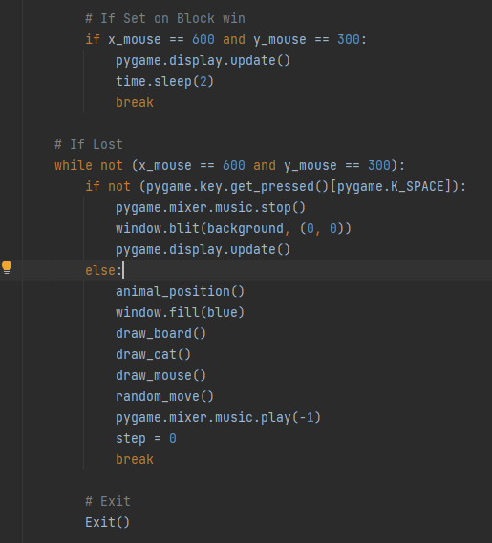

**In This Code:**

1. **If the mouse reaches the win block he will win and break this function and start the winning function [we will explain it later]**
2. **We made a chance for the user to play again by pressing SPACE.**

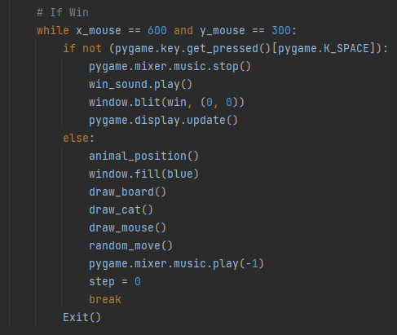

**In This Code:**

1. **If the user win, the winner background will start with its sound.**
2. **We made a chance to the user to play again by pressing SPACE.**

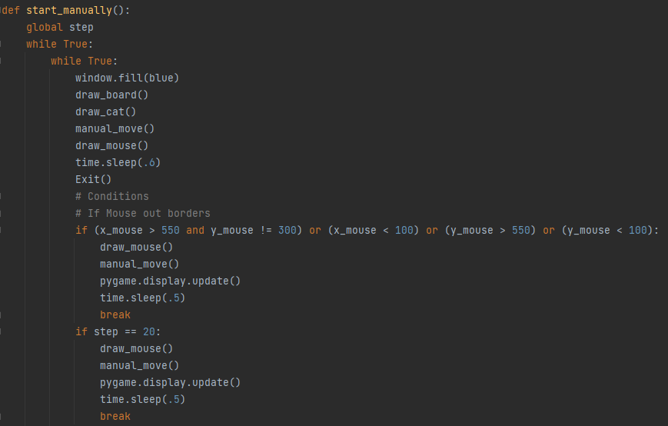

**In This Code:**

1. **This is function for manual moving.**
2. **All Codes Like Random moving....**

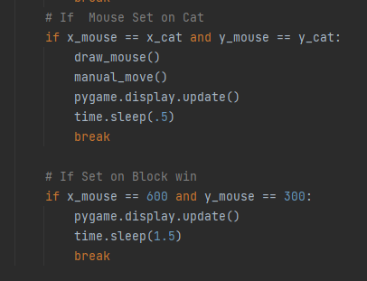

**In This Code:**

1. **There conditions like Random functions....**

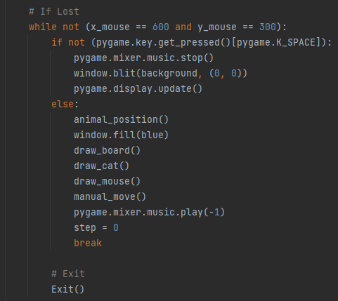

**In This Code:**

1. **These codes like random function.... [we made a chance to the user to play again]**

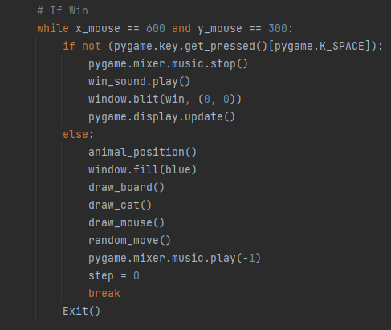

**In This Code:**

1. **These Codes Like random function.... [winning scenario and made a chance to the user to play again]**

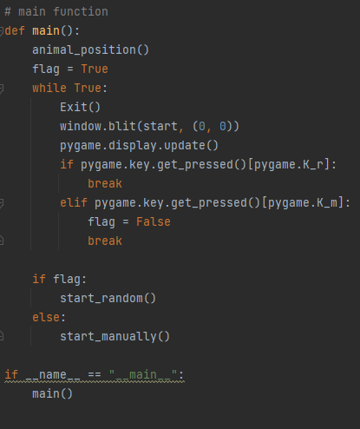

**In This Code:**

1. **This is the main function in the game, The program starts from here.**
2. **This gave the user a chance to choose between [random moving Or manual moving with (up, down, right, left Keys)]**

**\*Some Photos from Game:**

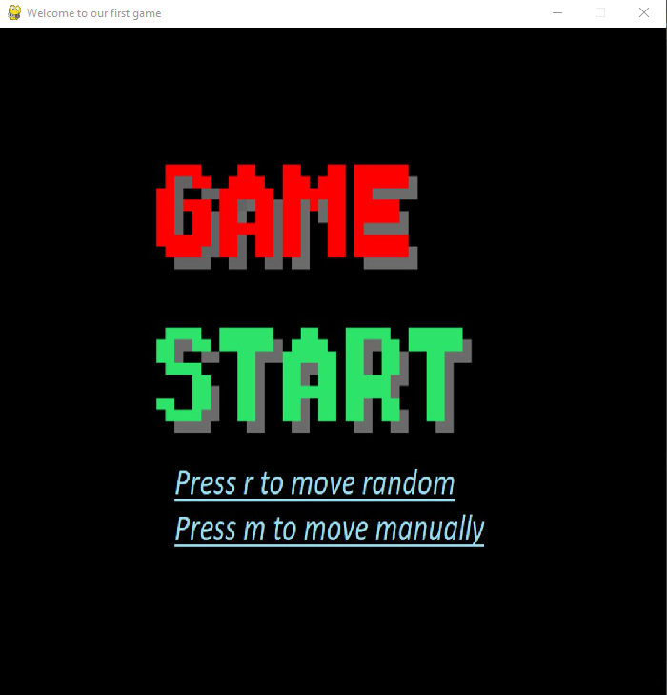

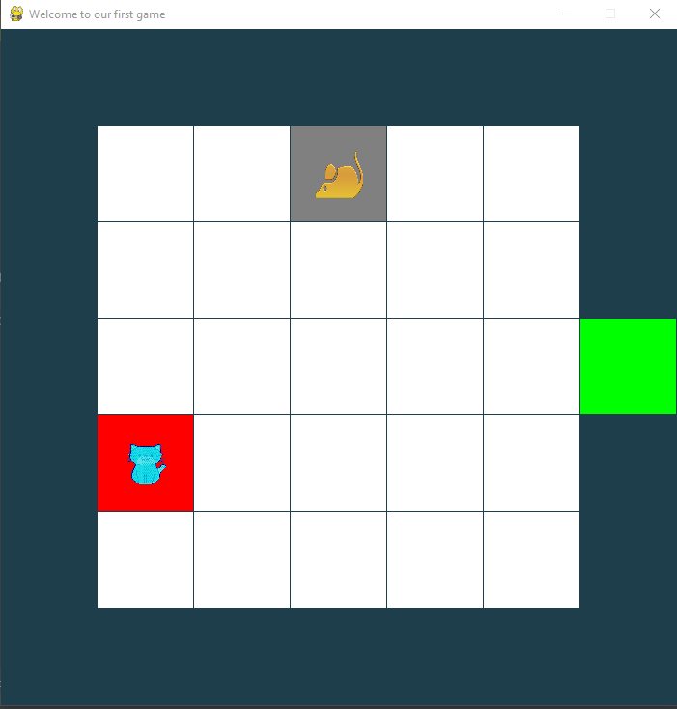

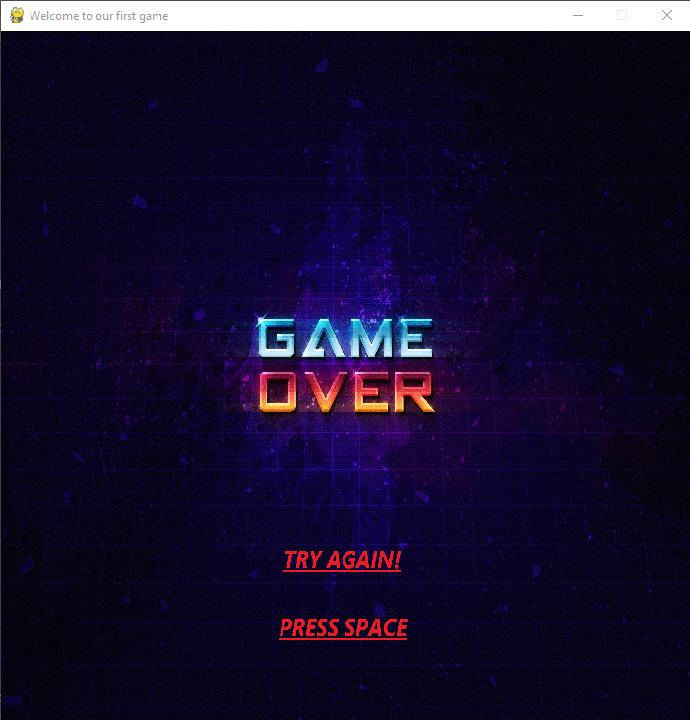



**Team 5 [Mahmoud Adel & Yomna Magdy]**

**Facilitators: [Nadine Essam & Ahmed Emad]**

**Game:**

**Mouse Escaping**